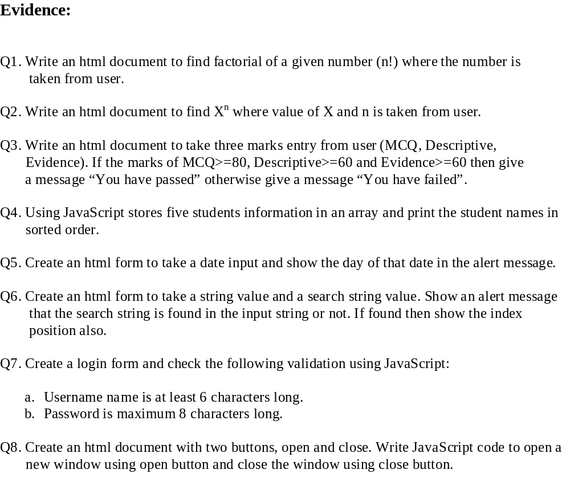
Q9. Find whether a number is prime or not. User will give the number.

